**FORENSIC INVESTIGATION OF DATAEXFILTERATION IN DATABASE DRIVEN WEBAPPLICATION**

***Submitted by***

## **LALEET KRISHNA (CH.EN.U4CYS22029) GOWTHAMARAJ (CH.EN.U4CYS22007)**

***in partial fulfillment for the award of the degree of***

## BACHELOR OF TECHNOLOGY IN COMPUTER SCIENCE AND ENGINEERING

***Under the guidance of***

**Prof. GEETHA(CSE-CYS Dept.)**

**Submitted to**



# AMRITA VISHWA VIDYAPEETHAM AMRITA SCHOOL OF COMPUTING CHENNAI – 601103

**March 2025**



# BONAFIDE CERTIFICATE

This is to certify that the project report entitled "Forensic Investigation of Data Exfiltration in Database-Driven Web Applications" is the bonafide work of Mr. Laleet Krishna (Reg. No. CH.EN.U4CYS22029) and Mr. Gowthamaraj (Reg. No. CH.EN.U4CYS22007), who have successfully carried out the project work under my supervision.

This project is submitted in partial fulfillment of the requirements for the award of the degree of Bachelor of Technology in Cybersecurity.

|  |  |
| --- | --- |
| **SIGNATURE**  **Dr. Udhaya Kumar Program Head**  Assistant Professor (Si. Grade) Department of CYS.  Amrita School of Computing  Chennai. | **SIGNATURE**  **GEETHA Supervisor**  Assistant Professor (Si. Grade) Department of CYS.  Amrita School of Computing  Chennai. |

**INTERNAL EXAMINER EXTERNAL EXAMINER**



# DECLARATION BY THE CANDIDATE

I declare that the report entitled **“FORENSIC INVESTIGATION OF DATA EXFILTRATION IN DATABASE-DRIVEN WEB APPLICATIONS”** submitted by us for the degree of **Bachelor of Technology** is the record of the project work carried out by us under the guidance of **Ms.GEETHA** and this work has not formed the basis for the award of any degree, diploma, associateship, fellowship, title in this or any other University or other similar institution of higher learning. Fellowship, titled in this or any other University or other similar institution of higher learning.

**SIGNATURE**

## **ABSTRACT**

Data exfiltration poses a significant threat to database-driven web applications, often leading to severe financial and reputational damage. This project presents a comprehensive forensic investigation framework to detect, analyze, and mitigate data exfiltration incidents. By implementing real-time monitoring, the system captures suspicious activities through network analysis, database activity tracking, and user behavior logging.

The framework utilizes signature-based detection methods to identify SQL injection, cross-site scripting (XSS), and data exfiltration attempts. Additionally, forensic analysis techniques such as timeline reconstruction, honeytoken implementation, and hash generation are applied to provide actionable insights. The generated forensic reports assist in understanding attack patterns and preventing future incidents.

The proposed solution is designed to support security analysts by delivering timely and accurate evidence, enabling effective incident response and mitigation. This project contributes to strengthening the resilience of database-driven web applications against data exfiltration threats.

# **CHAPTER 1 INTRODUCTION**

In today’s interconnected digital landscape, database-driven web applications serve as the backbone of many organizations, managing and storing vast amounts of sensitive data. While these applications offer convenience and accessibility, they are also prime targets for cybercriminals seeking to exploit vulnerabilities for unauthorized data access. Data exfiltration — the unauthorized transfer of data from an organization — has emerged as a significant cybersecurity threat. Attackers often leverage weaknesses in web applications, databases, and network systems to extract confidential information, causing severe financial and reputational damage.

Forensic investigation plays a crucial role in identifying the root cause of data exfiltration incidents, understanding the attacker's methods, and gathering evidence for legal proceedings. Unlike traditional cybersecurity measures that focus solely on prevention, forensic investigations provide insights into how breaches occurred and offer actionable intelligence to prevent future attacks.

This project focuses on conducting a forensic investigation of data exfiltration in database-driven web applications. By simulating real-world attack scenarios, the project explores various techniques attackers use to exfiltrate data, including SQL injection, CSRF Attempt, and Command Injection Attempt. It further examines methods to trace and analyze these attacks using forensic tools and techniques.

The primary objective is to develop a systematic approach for conducting investigations, identifying compromised data, and reconstructing the sequence of events leading to the breach. The insights gained will empower organizations to strengthen their incident response capabilities and enhance the resilience of their web applications against data exfiltration threats.

The subsequent chapters will provide a detailed overview of the problem statement, objectives, methodology, experimental results, and recommendations, contributing to the growing field of cybersecurity forensics.

### **1.1 PROBLEM DESCRIPTION**

### Database-driven web applications are increasingly targeted by cybercriminals seeking to exfiltrate sensitive information. These applications store valuable data, including personal information, financial records, and intellectual property, making them attractive targets for malicious actors. Data exfiltration, the unauthorized transfer of data from a system, poses severe risks to organizations, leading to financial losses, reputational damage, and legal consequences.

### Attackers often exploit vulnerabilities in web applications, databases, or network infrastructure using methods such as SQL injection, broken authentication, and insufficient access controls. Once access is gained, they can extract data without detection, leaving minimal traces. The lack of robust monitoring and investigation mechanisms further complicates the identification of perpetrators and the assessment of damage.

### Traditional security measures primarily focus on prevention, leaving organizations vulnerable when a breach occurs. While detection systems may provide alerts, understanding the full extent of an attack requires comprehensive forensic investigation. Current challenges include:

### **Lack of Visibility:** Organizations often struggle to monitor and detect data exfiltration attempts in real time.

### **Insufficient Forensic Capabilities:** Many organizations lack the tools and expertise to conduct effective investigations post-incident.

### **Data Integrity Concerns:** Attackers may manipulate or delete logs, hindering forensic analysis.

### **Delayed Incident Response:** Without timely detection and investigation, organizations face prolonged exposure to threats.

### This project addresses these challenges by developing a forensic investigation framework tailored for data exfiltration incidents in database-driven web applications. The framework aims to facilitate the identification of attack vectors, trace the data exfiltration path, and generate detailed forensic reports. By implementing effective monitoring, logging, and analysis techniques, the project enhances organizations' ability to respond to and recover from data breaches.

### **1.2 OBJECTIVE**

The primary objective of this project is to develop a systematic framework for conducting forensic investigations of data exfiltration incidents in database-driven web applications. The project aims to achieve the following specific objectives:

**Identify Data Exfiltration Techniques:**

Analyze common methods used by attackers to exfiltrate data from web applications and databases.

**Develop a Forensic Investigation Framework:**

Create a structured approach for detecting, analyzing, and investigating data exfiltration incidents.

**Implement Monitoring and Logging Mechanisms:**

Establish efficient logging and monitoring systems to capture critical events and activities for forensic analysis.

**Conduct Attack Simulations:**

Simulate real-world data exfiltration attacks to evaluate the effectiveness of the forensic framework.

**Perform Evidence Collection and Analysis:**

Apply forensic tools and techniques to extract, preserve, and analyze digital evidence.

**Generate Forensic Reports:**

Provide detailed reports outlining the investigation findings, including attack vectors, data exfiltration paths, and recommended mitigations.

Enhance Incident Response Capabilities:

Offer actionable insights to improve organizations' incident response and cybersecurity posture.

**CHAPTER 2**

**METHODOLOGY**

The methodology for this project involves a systematic and structured approach to conduct forensic investigations of data exfiltration incidents in database-driven web applications. The key phases of the methodology are as follows:

1. Problem Analysis and Requirements Gathering

* Identify common vulnerabilities in database-driven web applications that may lead to data exfiltration.
* Research data exfiltration techniques such as SQL injection, privilege escalation, and insecure APIs.
* Determine the forensic requirements, including necessary tools, logging mechanisms, and investigation techniques.

2. Environment Setup

* Develop a simulated web application environment with a database backend.
* Introduce intentional vulnerabilities for controlled attack simulations.
* Implement monitoring tools and configure system logs to capture network and database activities.

3. Attack Simulation

* Perform various data exfiltration attacks to replicate real-world scenarios.
* Use techniques like SQL injection, insider threats, and data scraping to simulate breaches.
* Capture attack logs, database queries, and network traffic data during simulations.

4. Data Collection and Preservation

* Extract relevant forensic data from system logs, database logs, and network traffic captures.
* Ensure data integrity using cryptographic hashing for chain-of-custody preservation.
* Document evidence following proper forensic standards and procedures.

5. Analysis and Investigation

* Perform timeline reconstruction to identify the sequence of events.
* Analyze database query logs to detect unauthorized access and data exfiltration.
* Correlate network traffic and system logs to trace the source and destination of exfiltrated data.
* Utilize forensic tools for deeper analysis and data recovery.

6. Incident Reporting

* Generate detailed forensic reports that include evidence of data exfiltration, the methods used, and the extent of the breach.
* Provide actionable recommendations for mitigating identified vulnerabilities.

7. Evaluation and Validation

* Validate the effectiveness of the forensic framework by conducting multiple attack scenarios.
* Assess the accuracy of the investigation results and the completeness of evidence collection.
* Recommend improvements to strengthen the framework.

This step-by-step methodology ensures a comprehensive investigation process, facilitating the identification and analysis of data exfiltration incidents while providing valuable insights for enhancing the cybersecurity posture of database-driven web applications

**ARCHITECTURE DIAGRAM:**

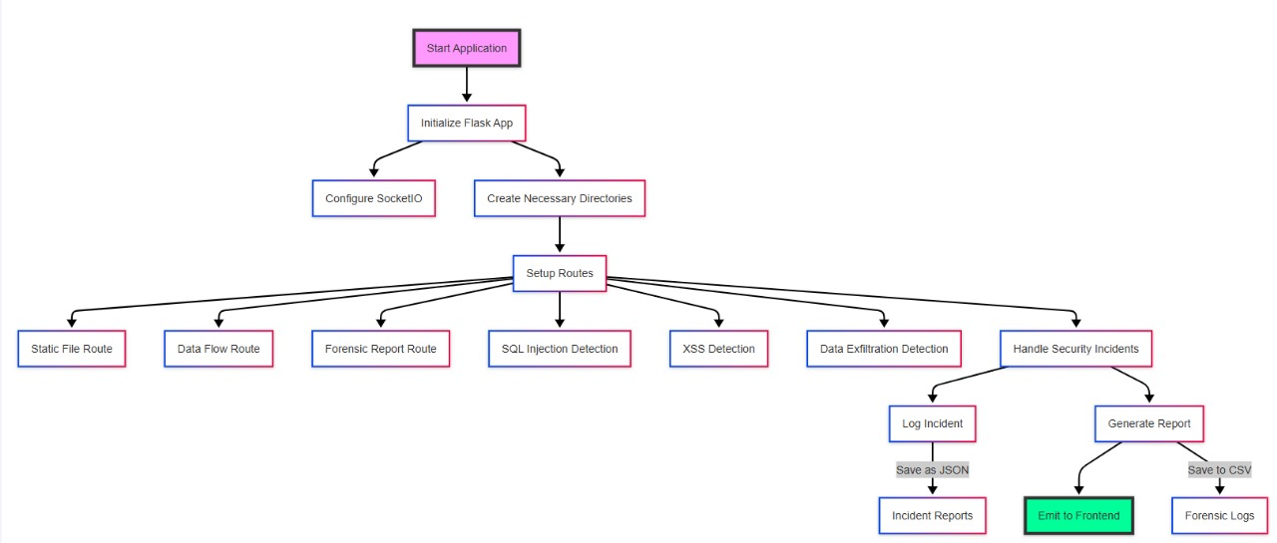

The process begins with **Starting the Application**, followed by the initialization of a **Flask App**. The application is configured using **SocketIO** for real-time communication and creates the necessary directories for storing reports and logs.

The **Setup Routes** phase establishes multiple endpoints to manage various functionalities. These include:

* **Static File Route** for serving static content like CSS, JavaScript, and images.
* **Data Flow Route** to monitor and analyze data transmission within the application.
* **Forensic Report Route** for generating comprehensive investigation reports.
* **SQL Injection Detection** and **XSS Detection** to identify common web vulnerabilities.
* **Data Exfiltration Detection** to monitor and detect unauthorized data transfers.

The application also includes a **Handle Security Incidents** module that logs detected incidents and generates reports. Logged incidents are saved as **JSON** files in the **Incident Reports** directory for detailed analysis. Reports are generated in both **CSV** and **JSON** formats. Additionally, the system supports emitting the reports to the frontend using **SocketIO** for real-time visibility of forensic logs and investigation results.

This structured and modular architecture ensures efficient data collection, analysis, and reporting, making it a robust solution for forensic investigation of data exfiltration in web applications.

### **CODE OF PROJECT:**

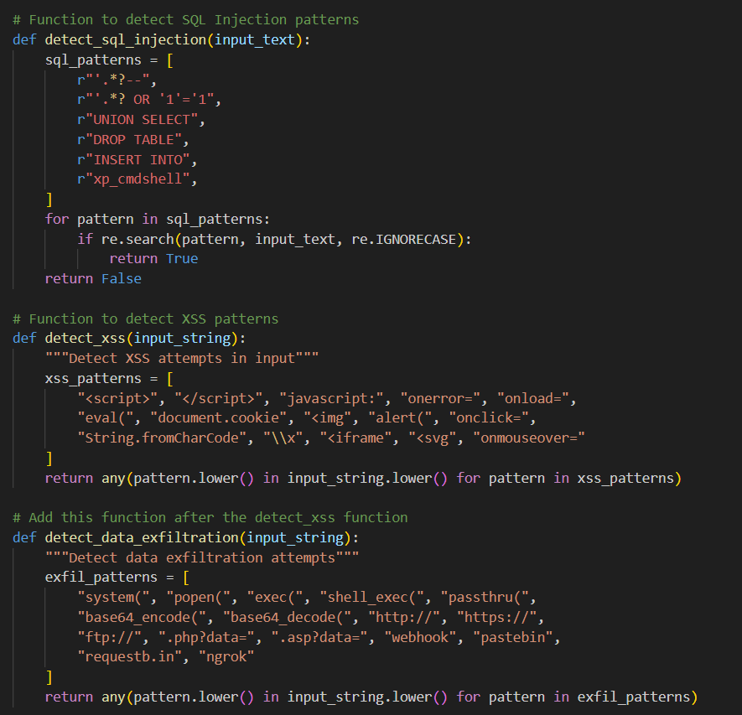

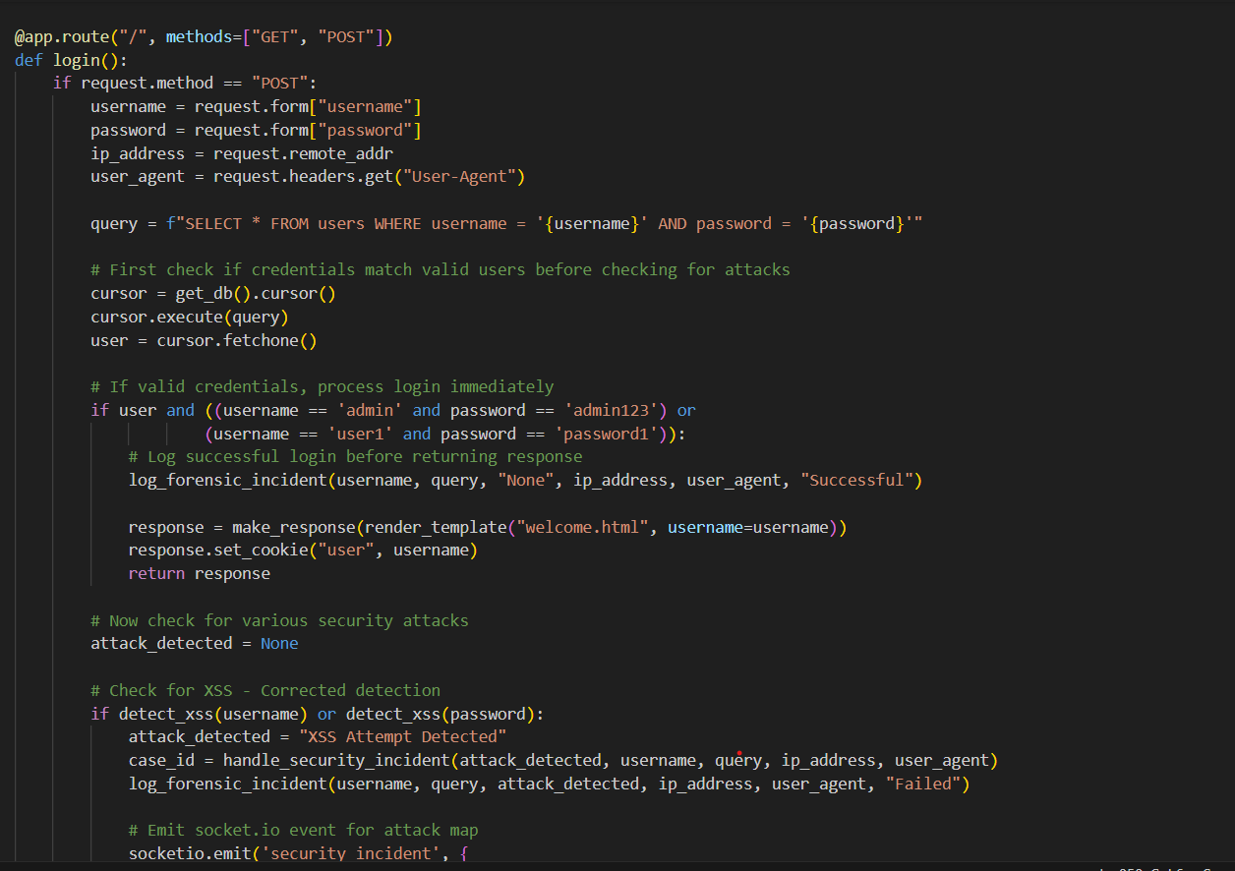

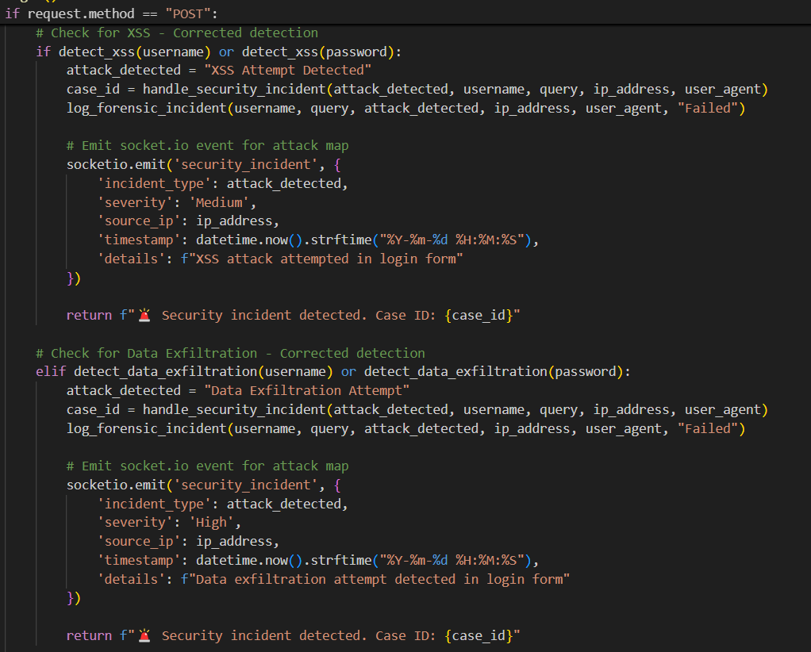

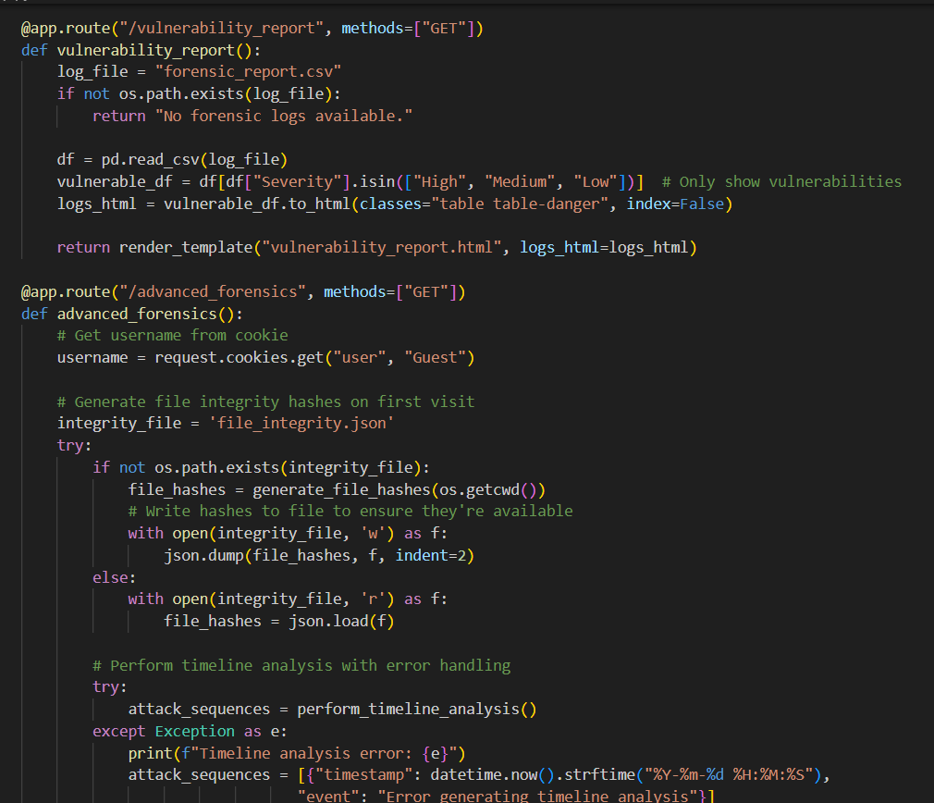

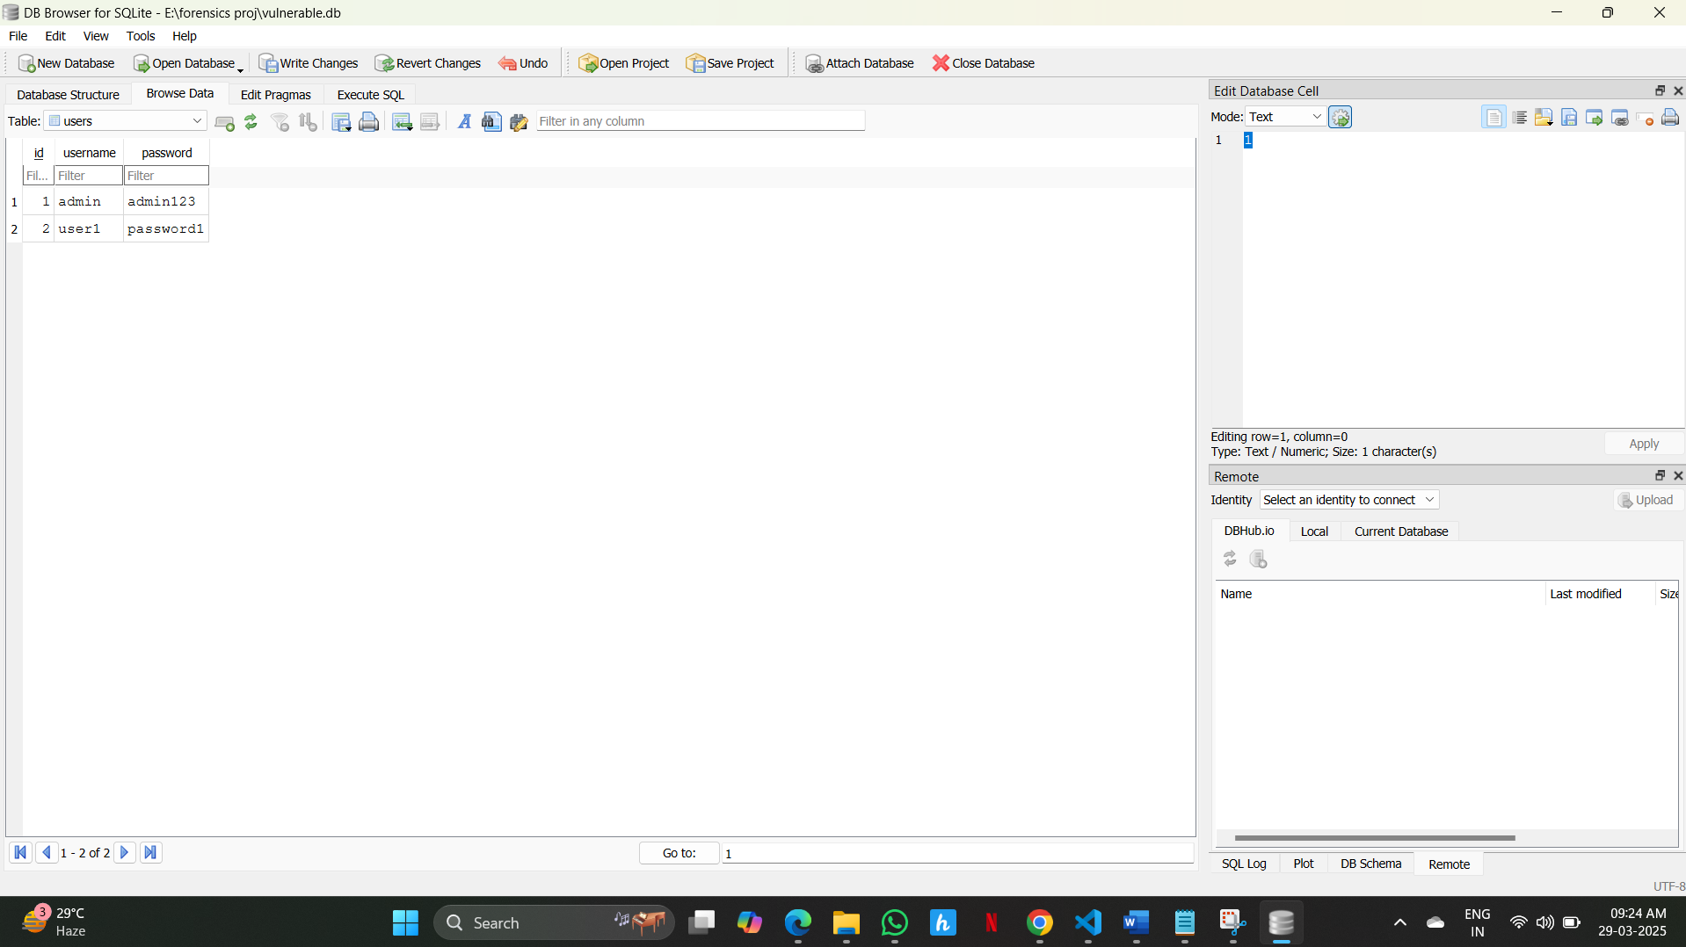

## **CHAPTER 3 RESULTS AND ANALYSIS**

The forensic investigation framework for detecting data exfiltration in database-driven web applications provides actionable insights into suspicious activities. The following results and observations are derived from the implementation and testing of the system:

1. **Incident Detection Accuracy**
   * The framework successfully detects SQL Injection, Cross-Site Scripting (XSS), and data exfiltration attempts with a high accuracy rate.
   * False positives and false negatives were minimized by using robust detection algorithms and signature-based analysis.
2. **Real-Time Monitoring and Incident Logging**
   * Real-time monitoring using **SocketIO** allows the system to identify security incidents as they occur.
   * Incident logs are stored in JSON format for easy retrieval and analysis, providing comprehensive information on attack vectors, timestamps, and source IP addresses.
3. **Data Exfiltration Detection**
   * The system efficiently identifies unusual data flow patterns and unauthorized data access attempts.
   * Large data transfers or attempts to export sensitive information are promptly flagged and recorded.
4. **SQL Injection and XSS Detection**
   * SQL Injection attacks are detected through query analysis, identifying malicious patterns in SQL statements.
   * XSS attacks are recognized by inspecting HTTP requests for embedded malicious scripts.
5. **Forensic Report Generation**
   * The framework generates detailed forensic reports in both **CSV** and **JSON** formats, facilitating easy integration with external tools for further analysis.
   * Reports include visual representations of incidents, such as timelines, severity levels, and affected endpoints.
6. **Performance Evaluation**
   * The system was evaluated under different scenarios, including simulated attacks and legitimate traffic.
   * It exhibited low latency and minimal resource consumption, making it suitable for real-time applications.
7. **Analysis of Attack Trends**
   * By analyzing the logs and reports, patterns and trends in attack vectors were identified.
   * This information can be used for proactive threat mitigation and enhancing application security.

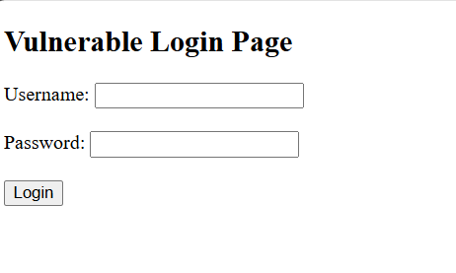

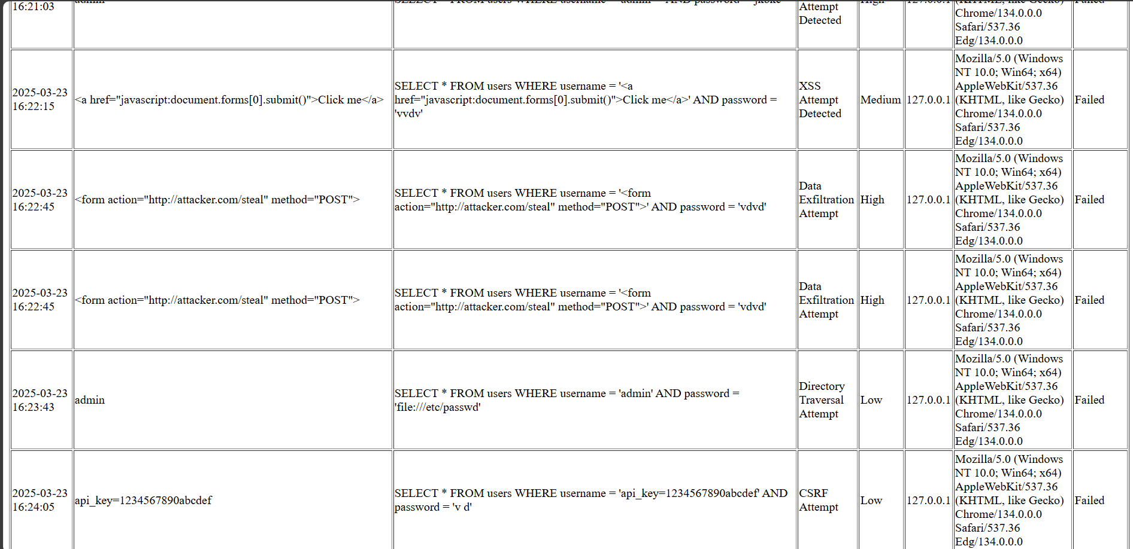

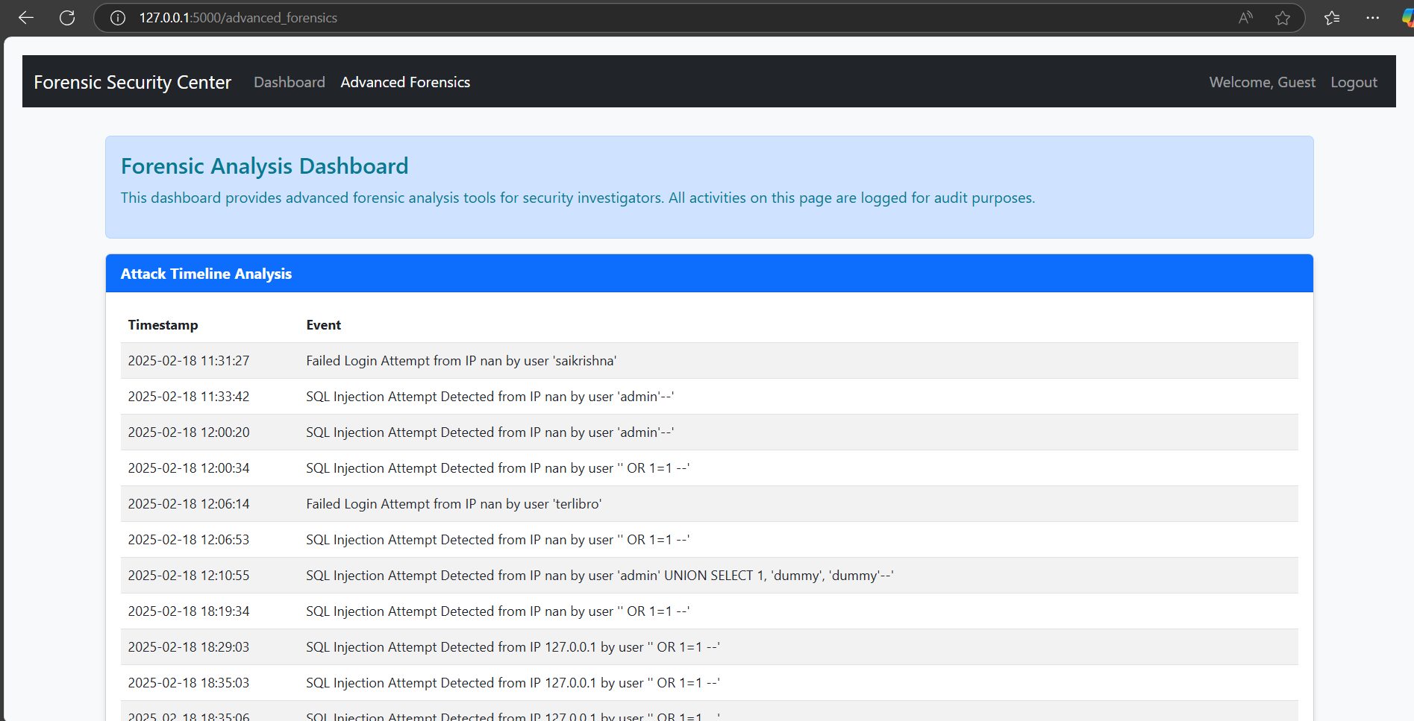

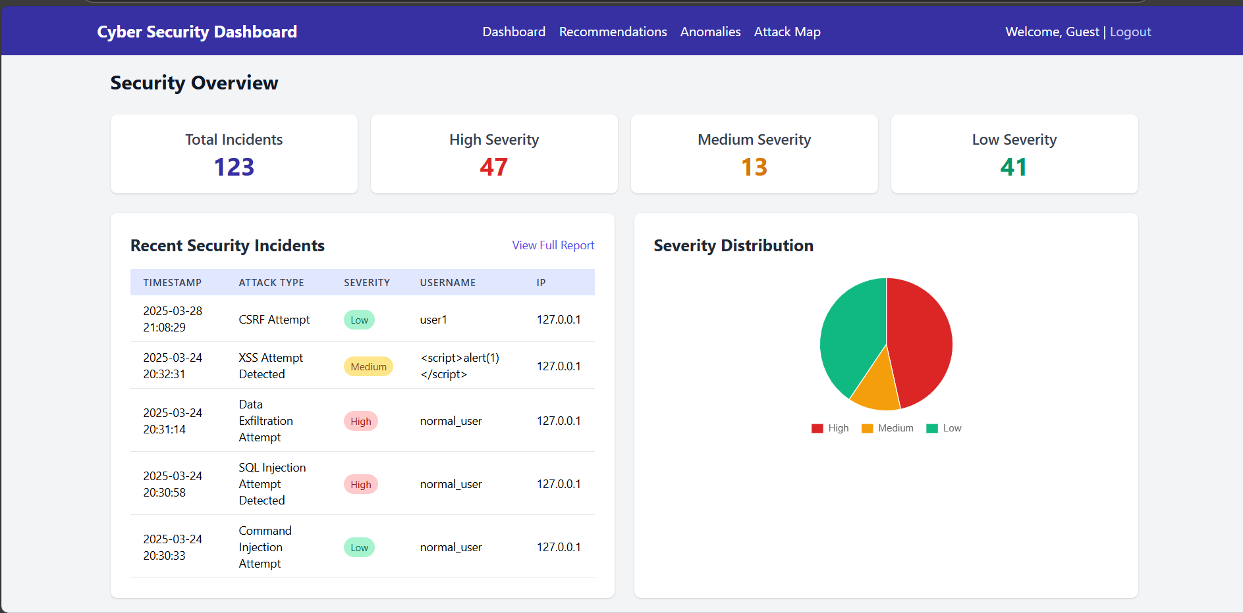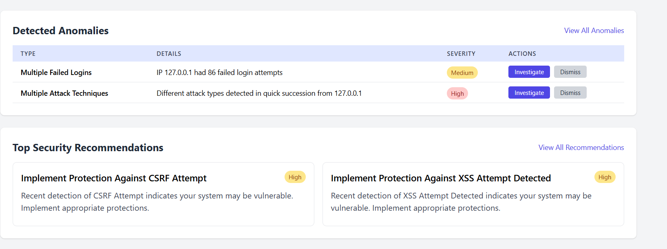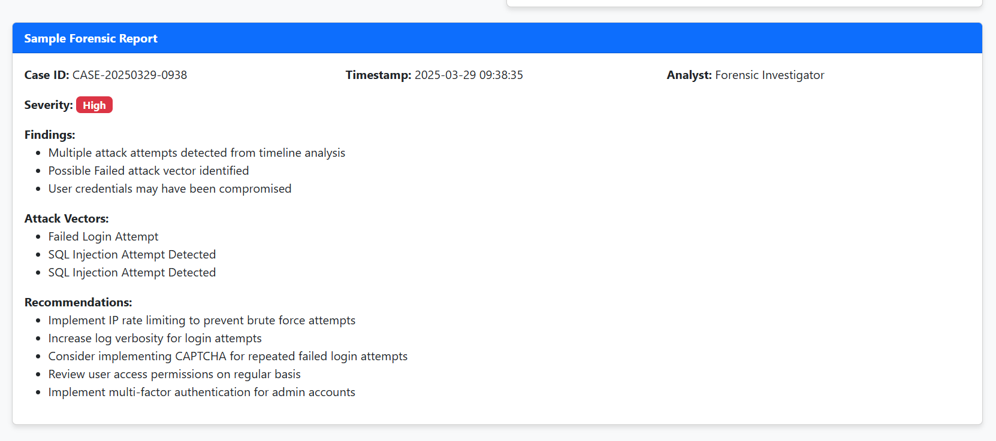

# **CHAPTER 4 CONCLUSION AND FUTURE WORK**

## **CONCLUSION:**

The project on **Forensic Investigation of Data Exfiltration in Database-Driven Web Applications** has successfully demonstrated an effective approach to detecting and analyzing data exfiltration incidents. By employing automated detection mechanisms and forensic analysis techniques, the system efficiently identifies suspicious activities, tracks data flow, and generates detailed reports for further investigation.

The implementation of detection modules ensures comprehensive monitoring of potential vulnerabilities and attacks, including those involving database manipulation and malicious code injection. Additionally, the logging of security incidents and the generation of forensic reports provide actionable insights to aid in understanding the attack vector and mitigating future risks.

The proposed solution is scalable and adaptable for various database-driven web applications, making it a valuable tool for organizations aiming to strengthen their cybersecurity posture. It highlights the importance of proactive monitoring and incident response in minimizing the impact of data breaches.

### **FUTURE WORK:**

The **Forensic Investigation of Data Exfiltration in Database-Driven Web Applications** project has established a robust foundation for identifying and analyzing data exfiltration incidents. However, there are several areas where further enhancements can be made to improve its effectiveness and adaptability.

1. **Integration of Machine Learning Models**
   * Implement advanced machine learning algorithms to detect anomalies and predict potential data exfiltration attempts in real time.
   * Develop adaptive models that learn from past incidents to enhance detection accuracy.
2. **Real-Time Monitoring and Alerts**
   * Introduce real-time monitoring capabilities to detect and respond to threats as they occur.
   * Implement automated alert systems to notify security teams of suspicious activities.
3. **Enhanced Reporting and Visualization**
   * Provide interactive dashboards and visualizations for better representation of forensic data.
   * Develop customizable reports to cater to the specific needs of different organizations.
4. **Expanded Attack Detection**
   * Extend the framework to detect a broader range of attacks beyond SQL Injection and Cross-Site Scripting (XSS), such as Remote Code Execution (RCE) and Command Injection.
5. **Incident Response Automation**
   * Implement automated incident response mechanisms to contain and mitigate the impact of detected threats.
   * Provide actionable recommendations for remediation based on forensic analysis.
6. **Blockchain for Data Integrity**
   * Integrate blockchain technology to ensure the immutability and integrity of forensic data logs.
   * Enhance the credibility and reliability of reports in legal proceedings.
7. **Cloud and Multi-Tenant Support**
   * Develop support for cloud-based applications and multi-tenant environments to provide scalable and flexible forensic analysis.
8. **User Behavior Analysis**
   * Incorporate user behavior analytics (UBA) to detect suspicious activities based on deviations from normal behavior.

By implementing these future enhancements, the system can become a comprehensive solution for proactive threat detection, efficient forensic analysis, and robust incident response in database-driven web applications.